**Exercícios Portas Lógicas**

Álgebra Booleana – parte 2

Mauricio Santana dos Santos / **RA:** 01202091

1. Dado o circuito abaixo faça a tabela verdade e a expressão booleana

**Circuito**  **Expressão booleana**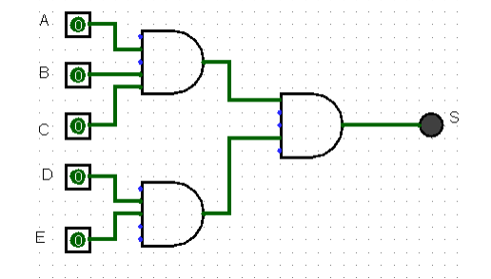

S= ((A*B*C)*(D*E))

**Tabela verdade**

| A | B | C | D | E | S1 (A*B*C) | S2(D*E) | S(S1 *S2) |
| --- | --- | --- | --- | --- | --- | --- | --- |
| 0 | 0 | 0 | 0 | 0 | 0 | 0 | 0 |
| 0 | 0 | 0 | 0 | 1 | 0 | 0 | 0 |
| 0 | 0 | 0 | 1 | 0 | 0 | 0 | 0 |
| 0 | 0 | 0 | 1 | 1 | 0 | 1 | 0 |
| 0 | 0 | 1 | 0 | 0 | 0 | 0 | 0 |
| 0 | 0 | 1 | 0 | 1 | 0 | 0 | 0 |
| 0 | 0 | 1 | 1 | 0 | 0 | 0 | 0 |
| 0 | 0 | 1 | 1 | 1 | 0 | 1 | 0 |
| 0 | 1 | 0 | 0 | 0 | 0 | 0 | 0 |
| 0 | 1 | 0 | 0 | 1 | 0 | 0 | 0 |
| 0 | 1 | 0 | 1 | 0 | 0 | 0 | 0 |
| 0 | 1 | 0 | 1 | 1 | 0 | 1 | 0 |
| 0 | 1 | 1 | 0 | 0 | 0 | 0 | 0 |
| 0 | 1 | 1 | 0 | 1 | 0 | 0 | 0 |
| 0 | 1 | 1 | 1 | 0 | 0 | 0 | 0 |
| 0 | 1 | 1 | 1 | 1 | 0 | 1 | 0 |
| 1 | 0 | 0 | 0 | 0 | 0 | 0 | 0 |
| 1 | 0 | 0 | 0 | 1 | 0 | 0 | 0 |
| 1 | 0 | 0 | 1 | 0 | 0 | 0 | 0 |
| 1 | 0 | 0 | 1 | 1 | 0 | 1 | 0 |
| 1 | 0 | 1 | 0 | 0 | 0 | 0 | 0 |
| 1 | 0 | 1 | 0 | 1 | 0 | 0 | 0 |
| 1 | 0 | 1 | 1 | 0 | 0 | 0 | 0 |
| 1 | 0 | 1 | 1 | 1 | 0 | 1 | 0 |
| 1 | 1 | 0 | 0 | 0 | 0 | 0 | 0 |
| 1 | 1 | 0 | 0 | 1 | 0 | 0 | 0 |
| 1 | 1 | 0 | 1 | 0 | 0 | 0 | 0 |
| 1 | 1 | 0 | 1 | 1 | 0 | 1 | 0 |
| 1 | 1 | 1 | 0 | 0 | 1 | 0 | 0 |
| 1 | 1 | 1 | 0 | 1 | 1 | 0 | 0 |
| 1 | 1 | 1 | 1 | 0 | 1 | 0 | 0 |
| 1 | 1 | 1 | 1 | 1 | 1 | 1 | 1 |

1. Dada a expressão boolena apresente o circuito e a tabela verdade

**Circuito**  **Expressão booleana**

S = ( AC) + (B+D) + (EF)  
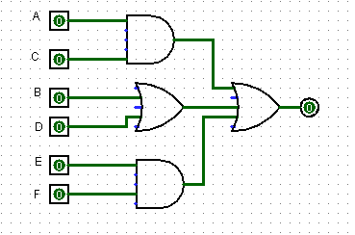

**Tabela verdade**

| A | B | C | D | E | F | S1 (A*C) | S2 (B+D) | S3 (E*F) | S (S1+S2+S3) |
| --- | --- | --- | --- | --- | --- | --- | --- | --- | --- |
| 0 | 0 | 0 | 0 | 0 | 0 | 0 | 0 | 0 | 0 |
| 0 | 0 | 0 | 0 | 0 | 1 | 0 | 0 | 0 | 0 |
| 0 | 0 | 0 | 0 | 1 | 0 | 0 | 0 | 0 | 0 |
| 0 | 0 | 0 | 0 | 1 | 1 | 0 | 0 | 1 | 0 |
| 0 | 0 | 0 | 1 | 0 | 0 | 0 | 1 | 0 | 0 |
| 0 | 0 | 0 | 1 | 0 | 1 | 0 | 1 | 0 | 0 |
| 0 | 0 | 0 | 1 | 1 | 0 | 0 | 1 | 0 | 0 |
| 0 | 0 | 0 | 1 | 1 | 1 | 0 | 1 | 1 | 0 |
| 0 | 0 | 1 | 0 | 0 | 0 | 0 | 0 | 0 | 0 |
| 0 | 0 | 1 | 0 | 0 | 1 | 0 | 0 | 0 | 0 |
| 0 | 0 | 1 | 0 | 1 | 0 | 0 | 0 | 0 | 0 |
| 0 | 0 | 1 | 0 | 1 | 1 | 0 | 0 | 1 | 0 |
| 0 | 0 | 1 | 1 | 0 | 0 | 0 | 1 | 0 | 0 |
| 0 | 0 | 1 | 1 | 0 | 1 | 0 | 1 | 0 | 0 |
| 0 | 0 | 1 | 1 | 1 | 0 | 0 | 1 | 0 | 0 |
| 0 | 0 | 1 | 1 | 1 | 1 | 0 | 1 | 1 | 0 |
| 0 | 1 | 0 | 0 | 0 | 0 | 0 | 1 | 0 | 0 |
| 0 | 1 | 0 | 0 | 0 | 1 | 0 | 1 | 0 | 0 |
| 0 | 1 | 0 | 0 | 1 | 0 | 0 | 1 | 0 | 0 |
| 0 | 1 | 0 | 0 | 1 | 1 | 0 | 1 | 1 | 0 |
| 0 | 1 | 0 | 1 | 0 | 0 | 0 | 1 | 0 | 0 |
| 0 | 1 | 0 | 1 | 0 | 1 | 0 | 1 | 0 | 0 |
| 0 | 1 | 0 | 1 | 1 | 0 | 0 | 1 | 0 | 0 |
| 0 | 1 | 0 | 1 | 1 | 1 | 0 | 1 | 1 | 0 |
| 0 | 1 | 1 | 0 | 0 | 0 | 0 | 1 | 0 | 0 |
| 0 | 1 | 1 | 0 | 0 | 1 | 0 | 1 | 0 | 0 |
| 0 | 1 | 1 | 0 | 1 | 0 | 0 | 1 | 0 | 0 |
| 0 | 1 | 1 | 0 | 1 | 1 | 0 | 1 | 1 | 0 |
| 0 | 1 | 1 | 1 | 0 | 0 | 0 | 1 | 0 | 0 |
| 0 | 1 | 1 | 1 | 0 | 1 | 0 | 1 | 0 | 0 |
| 0 | 1 | 1 | 1 | 1 | 0 | 0 | 1 | 0 | 0 |
| 0 | 1 | 1 | 1 | 1 | 1 | 0 | 1 | 1 | 0 |
| 1 | 0 | 0 | 0 | 0 | 0 | 0 | 0 | 0 | 0 |
| 1 | 0 | 0 | 0 | 0 | 1 | 0 | 0 | 0 | 0 |
| 1 | 0 | 0 | 0 | 1 | 0 | 0 | 0 | 0 | 0 |
| 1 | 0 | 0 | 0 | 1 | 1 | 0 | 0 | 1 | 0 |
| 1 | 0 | 0 | 1 | 0 | 0 | 0 | 1 | 0 | 0 |
| 1 | 0 | 0 | 1 | 0 | 1 | 0 | 1 | 0 | 0 |
| 1 | 0 | 0 | 1 | 1 | 0 | 0 | 1 | 0 | 0 |
| 1 | 0 | 0 | 1 | 1 | 1 | 0 | 1 | 0 | 0 |
| 1 | 0 | 1 | 0 | 0 | 0 | 1 | 0 | 1 | 0 |
| 1 | 0 | 1 | 0 | 0 | 1 | 1 | 0 | 0 | 0 |
| 1 | 0 | 1 | 0 | 1 | 0 | 1 | 0 | 0 | 0 |
| 1 | 0 | 1 | 0 | 1 | 1 | 1 | 0 | 0 | 0 |
| 1 | 0 | 1 | 1 | 0 | 0 | 1 | 1 | 1 | 1 |
| 1 | 0 | 1 | 1 | 0 | 1 | 1 | 1 | 0 | 0 |
| 1 | 0 | 1 | 1 | 1 | 0 | 1 | 1 | 0 | 0 |
| 1 | 0 | 1 | 1 | 1 | 1 | 1 | 1 | 0 | 0 |
| 1 | 1 | 0 | 0 | 0 | 0 | 0 | 1 | 1 | 0 |
| 1 | 1 | 0 | 0 | 0 | 1 | 0 | 1 | 0 | 0 |
| 1 | 1 | 0 | 0 | 1 | 0 | 0 | 1 | 0 | 0 |
| 1 | 1 | 0 | 0 | 1 | 1 | 0 | 1 | 0 | 0 |
| 1 | 1 | 0 | 1 | 0 | 0 | 0 | 1 | 1 | 0 |
| 1 | 1 | 0 | 1 | 0 | 1 | 0 | 1 | 0 | 0 |
| 1 | 1 | 0 | 1 | 1 | 0 | 0 | 1 | 0 | 0 |
| 1 | 1 | 0 | 1 | 1 | 1 | 0 | 1 | 0 | 0 |
| 1 | 1 | 1 | 0 | 0 | 0 | 1 | 1 | 1 | 1 |
| 1 | 1 | 1 | 0 | 0 | 1 | 1 | 1 | 0 | 0 |
| 1 | 1 | 1 | 0 | 1 | 0 | 1 | 1 | 0 | 0 |
| 1 | 1 | 1 | 0 | 1 | 1 | 1 | 1 | 0 | 0 |
| 1 | 1 | 1 | 1 | 0 | 0 | 1 | 1 | 1 | 1 |
| 1 | 1 | 1 | 1 | 0 | 1 | 1 | 1 | 0 | 0 |
| 1 | 1 | 1 | 1 | 1 | 0 | 1 | 1 | 0 | 0 |
| 1 | 1 | 1 | 1 | 1 | 1 | 1 | 1 | 0 | 0 |

1. Dada a tabela verdade a seguir, desenhe o seu circuito lógico e a expressão booleana

**Tabela verdade Circuito**

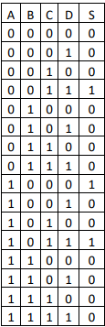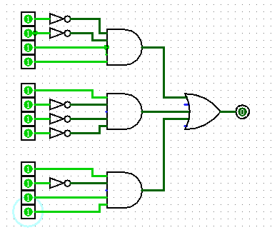



**Expressão booleana**

S=(!A*!B*C*D) + S=(A*!B*!C*!D) + S=(A*!B*C*D)

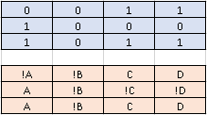

1. Dado o circuito abaixo faça a tabela verdade e a expressão booleana

**Circuito**  **Expressão booleana**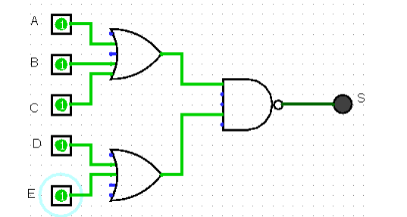

S=((A+B+C) * (D+E))

**Tabela verdade**

| A | B | C | D | E | S1 (A+B+C) | S2(D+E) | S(S1 *S2) |
| --- | --- | --- | --- | --- | --- | --- | --- |
| 0 | 0 | 0 | 0 | 0 | 0 | 0 | 0 |
| 0 | 0 | 0 | 0 | 1 | 0 | 0 | 0 |
| 0 | 0 | 0 | 1 | 0 | 0 | 0 | 0 |
| 0 | 0 | 0 | 1 | 1 | 0 | 1 | 0 |
| 0 | 0 | 1 | 0 | 0 | 0 | 0 | 0 |
| 0 | 0 | 1 | 0 | 1 | 0 | 0 | 0 |
| 0 | 0 | 1 | 1 | 0 | 0 | 0 | 0 |
| 0 | 0 | 1 | 1 | 1 | 0 | 1 | 0 |
| 0 | 1 | 0 | 0 | 0 | 0 | 0 | 0 |
| 0 | 1 | 0 | 0 | 1 | 0 | 0 | 0 |
| 0 | 1 | 0 | 1 | 0 | 0 | 0 | 0 |
| 0 | 1 | 0 | 1 | 1 | 0 | 1 | 0 |
| 0 | 1 | 1 | 0 | 0 | 0 | 0 | 0 |
| 0 | 1 | 1 | 0 | 1 | 0 | 0 | 0 |
| 0 | 1 | 1 | 1 | 0 | 0 | 0 | 0 |
| 0 | 1 | 1 | 1 | 1 | 0 | 1 | 0 |
| 1 | 0 | 0 | 0 | 0 | 0 | 0 | 0 |
| 1 | 0 | 0 | 0 | 1 | 0 | 0 | 0 |
| 1 | 0 | 0 | 1 | 0 | 0 | 0 | 0 |
| 1 | 0 | 0 | 1 | 1 | 0 | 1 | 0 |
| 1 | 0 | 1 | 0 | 0 | 0 | 0 | 0 |
| 1 | 0 | 1 | 0 | 1 | 0 | 0 | 0 |
| 1 | 0 | 1 | 1 | 0 | 0 | 0 | 0 |
| 1 | 0 | 1 | 1 | 1 | 0 | 1 | 0 |
| 1 | 1 | 0 | 0 | 0 | 0 | 0 | 0 |
| 1 | 1 | 0 | 0 | 1 | 0 | 0 | 0 |
| 1 | 1 | 0 | 1 | 0 | 0 | 0 | 0 |
| 1 | 1 | 0 | 1 | 1 | 0 | 1 | 0 |
| 1 | 1 | 1 | 0 | 0 | 1 | 0 | 0 |
| 1 | 1 | 1 | 0 | 1 | 1 | 0 | 0 |
| 1 | 1 | 1 | 1 | 0 | 1 | 0 | 0 |
| 1 | 1 | 1 | 1 | 1 | 1 | 1 | 1 |

1. Dada a expressão boolena apresente o circuito e a tabela verdade

**Expressão booleana Circuito**

S = A(B+D) + (EF) + C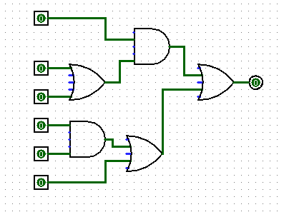

**Tabela verdade**

| A | B | C | D | E | F | S1(B+D) | S2 (E*F) | S3 (S1 *A) | S4 (S2 +C) | S=(S3+S4) |
| --- | --- | --- | --- | --- | --- | --- | --- | --- | --- | --- |
| 0 | 0 | 0 | 0 | 0 | 0 | 0 | 0 | 0 | 0 | 0 |
| 0 | 0 | 0 | 0 | 0 | 1 | 0 | 0 | 0 | 0 | 0 |
| 0 | 0 | 0 | 0 | 1 | 0 | 0 | 0 | 0 | 0 | 0 |
| 0 | 0 | 0 | 0 | 1 | 1 | 0 | 1 | 0 | 1 | 1 |
| 0 | 0 | 0 | 1 | 0 | 0 | 1 | 0 | 0 | 0 | 0 |
| 0 | 0 | 0 | 1 | 0 | 1 | 1 | 0 | 0 | 0 | 0 |
| 0 | 0 | 0 | 1 | 1 | 0 | 1 | 0 | 0 | 0 | 0 |
| 0 | 0 | 0 | 1 | 1 | 1 | 1 | 1 | 0 | 1 | 1 |
| 0 | 0 | 1 | 0 | 0 | 0 | 0 | 0 | 0 | 1 | 1 |
| 0 | 0 | 1 | 0 | 0 | 1 | 0 | 0 | 0 | 1 | 1 |
| 0 | 0 | 1 | 0 | 1 | 0 | 0 | 0 | 0 | 1 | 1 |
| 0 | 0 | 1 | 0 | 1 | 1 | 0 | 1 | 0 | 1 | 1 |
| 0 | 0 | 1 | 1 | 0 | 0 | 1 | 0 | 0 | 1 | 1 |
| 0 | 0 | 1 | 1 | 0 | 1 | 1 | 0 | 0 | 1 | 1 |
| 0 | 0 | 1 | 1 | 1 | 0 | 1 | 0 | 0 | 1 | 1 |
| 0 | 0 | 1 | 1 | 1 | 1 | 1 | 1 | 0 | 1 | 1 |
| 0 | 1 | 0 | 0 | 0 | 0 | 1 | 0 | 0 | 0 | 0 |
| 0 | 1 | 0 | 0 | 0 | 1 | 1 | 0 | 0 | 0 | 0 |
| 0 | 1 | 0 | 0 | 1 | 0 | 1 | 0 | 0 | 0 | 0 |
| 0 | 1 | 0 | 0 | 1 | 1 | 1 | 1 | 0 | 1 | 1 |
| 0 | 1 | 0 | 1 | 0 | 0 | 1 | 0 | 0 | 0 | 0 |
| 0 | 1 | 0 | 1 | 0 | 1 | 1 | 0 | 0 | 0 | 0 |
| 0 | 1 | 0 | 1 | 1 | 0 | 1 | 0 | 0 | 0 | 0 |
| 0 | 1 | 0 | 1 | 1 | 1 | 1 | 1 | 0 | 1 | 1 |
| 0 | 1 | 1 | 0 | 0 | 0 | 1 | 0 | 0 | 1 | 1 |
| 0 | 1 | 1 | 0 | 0 | 1 | 1 | 0 | 0 | 1 | 1 |
| 0 | 1 | 1 | 0 | 1 | 0 | 1 | 0 | 0 | 1 | 1 |
| 0 | 1 | 1 | 0 | 1 | 1 | 1 | 1 | 0 | 1 | 1 |
| 0 | 1 | 1 | 1 | 0 | 0 | 1 | 0 | 0 | 1 | 1 |
| 0 | 1 | 1 | 1 | 0 | 1 | 1 | 0 | 0 | 1 | 1 |
| 0 | 1 | 1 | 1 | 1 | 0 | 1 | 0 | 0 | 1 | 1 |
| 0 | 1 | 1 | 1 | 1 | 1 | 1 | 1 | 0 | 1 | 1 |
| 1 | 0 | 0 | 0 | 0 | 0 | 0 | 0 | 0 | 0 | 0 |
| 1 | 0 | 0 | 0 | 0 | 1 | 0 | 0 | 0 | 0 | 0 |
| 1 | 0 | 0 | 0 | 1 | 0 | 0 | 0 | 0 | 0 | 0 |
| 1 | 0 | 0 | 0 | 1 | 1 | 0 | 1 | 0 | 1 | 1 |
| 1 | 0 | 0 | 1 | 0 | 0 | 1 | 0 | 1 | 0 | 1 |
| 1 | 0 | 0 | 1 | 0 | 1 | 1 | 0 | 1 | 0 | 1 |
| 1 | 0 | 0 | 1 | 1 | 0 | 1 | 0 | 1 | 0 | 1 |
| 1 | 0 | 0 | 1 | 1 | 1 | 1 | 1 | 1 | 1 | 1 |
| 1 | 0 | 1 | 0 | 0 | 0 | 0 | 0 | 0 | 1 | 1 |
| 1 | 0 | 1 | 0 | 0 | 1 | 0 | 0 | 0 | 1 | 1 |
| 1 | 0 | 1 | 0 | 1 | 0 | 0 | 0 | 0 | 1 | 1 |
| 1 | 0 | 1 | 0 | 1 | 1 | 0 | 1 | 0 | 1 | 1 |
| 1 | 0 | 1 | 1 | 0 | 0 | 1 | 0 | 1 | 1 | 1 |
| 1 | 0 | 1 | 1 | 0 | 1 | 1 | 0 | 1 | 1 | 1 |
| 1 | 0 | 1 | 1 | 1 | 0 | 1 | 0 | 1 | 1 | 1 |
| 1 | 0 | 1 | 1 | 1 | 1 | 1 | 1 | 1 | 1 | 1 |
| 1 | 1 | 0 | 0 | 0 | 0 | 1 | 0 | 1 | 0 | 1 |
| 1 | 1 | 0 | 0 | 0 | 1 | 1 | 0 | 1 | 0 | 1 |
| 1 | 1 | 0 | 0 | 1 | 0 | 1 | 0 | 1 | 0 | 1 |
| 1 | 1 | 0 | 0 | 1 | 1 | 1 | 1 | 1 | 1 | 1 |
| 1 | 1 | 0 | 1 | 0 | 0 | 1 | 0 | 1 | 0 | 1 |
| 1 | 1 | 0 | 1 | 0 | 1 | 1 | 0 | 1 | 0 | 1 |
| 1 | 1 | 0 | 1 | 1 | 0 | 1 | 0 | 1 | 0 | 1 |
| 1 | 1 | 0 | 1 | 1 | 1 | 1 | 1 | 1 | 1 | 1 |
| 1 | 1 | 1 | 0 | 0 | 0 | 1 | 0 | 1 | 1 | 1 |
| 1 | 1 | 1 | 0 | 0 | 1 | 1 | 0 | 1 | 1 | 1 |
| 1 | 1 | 1 | 0 | 1 | 0 | 1 | 0 | 1 | 1 | 1 |
| 1 | 1 | 1 | 0 | 1 | 1 | 1 | 1 | 1 | 1 | 1 |
| 1 | 1 | 1 | 1 | 0 | 0 | 1 | 0 | 1 | 1 | 1 |
| 1 | 1 | 1 | 1 | 0 | 1 | 1 | 0 | 1 | 1 | 1 |
| 1 | 1 | 1 | 1 | 1 | 0 | 1 | 0 | 1 | 1 | 1 |
| 1 | 1 | 1 | 1 | 1 | 1 | 1 | 1 | 1 | 1 | 1 |

1. Dada a tabela verdade a seguir, desenhe o seu circuito lógico e a expressão booleana

**Tabela verdade Circuito**

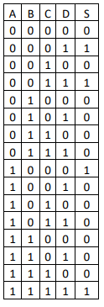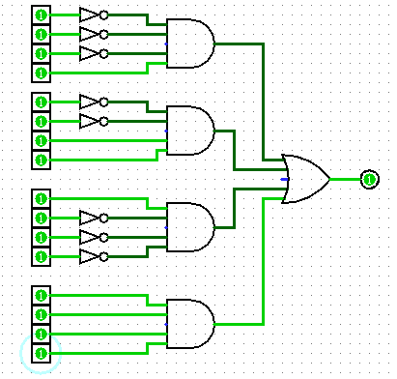



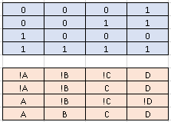

**Expressão booleana**

S =(!A*!B*!C*D) + S=(!A*!B*C*D) + S=(A*!B*!C*!D) + S= (A*B*C*D)